**Genotype specific host ontogeny is a robust driver of the rate of epiphytic lichen community assembly across contrasting environments**

L.J. Lamit, M.K. Lau, R. Reese Næsborg, T. Wojtowicz, T.G. Whitham, C.A. Gehring

Department of Biological Sciences and Merriam-Powell Center for Environmental Research, Northern Arizona University, Flagstaff, AZ 86011.

**Corresponding author**: Louis J. Lamit, Department of Biological Sciences, Northern Arizona University, P.O. Box 5640 Flagstaff, AZ 86011-5640. E-mail: ljl47@nau.edu, Phone: (928) 523-9138, Fax: (928) 523-7500

**ABSTRACT**

A major emphasis of the field of community genetics focuses on understanding the influence of genetic variation within a species on entire ecological communities. Although the influence of plant genotype on associated communities is well-documented for organisms such as arthropods, critics have argued that there is still much progress to be made before community genetics can be considered a mature scientific discipline. Here we employ an underutilized but ecologically important group of plant-associated organisms, epiphytic bark lichens, to understand the relative importance of *Populus angustifolia* (narrowleaf cottonwood) genotype and environment on the structure of associated organisms within the context of community assembly and host ontogeny. Several key findings emerged. 1) Tree genotype explained up to 33% of the variation in lichen community traits in a single common garden. 2) Across common gardens located within very different habitats, tree genotype explained up to approximately one quarter of the variation in lichen community attributes, whereas the garden environmental effect explained less than 8% in the few cases it was significant, and there were no genotype X garden interactions. These patterns did not change when considering a set of genotypes collected along the length of a river system or from within a single site. 3) The timing in the ontogenetic shift from smooth to rough bark emerged as a likely mechanism by which tree genotype influenced lichens. 4) Variation in bark roughness among tree genotypes of the same age reflected a genetically influenced gradient in community assembly, similar to that seen on trees of different ages. These findings indicate that host genetic influences on lichens may remain in natural habitats with heterogeneous environments. Furthermore, they point to the role that organisms outside the typical sphere of community genetics can play in addressing critical issues within the developing field and in connecting plant genotype effects to long-established streams of ecological research.

*Key words*: bark traits, community assembly, genotype, heritability, lichen, *Populus angustifolia*, structural equation modeling

**INTRODUCTION**

A primary goal of the field of community genetics seeks to understand how genotypic differences among individuals within species influences entire communities of interacting taxa (Antonovics 1992, Whitham et al. 2006). By focusing on one of the fundamental units important to biodiversity and evolution, the genotype, community genetics has the potential to unite the fields of community ecology, evolutionary biology, and genetics (Antonovics 1992, Whitham et al. 2006, Wade 2007), however there are still several strides to be taken before community genetics can be considered an important and lasting discipline. First, because of its roots in plant-enemy interactions, community genetics focuses intensively on arthropod responses to plant genotype (e.g., Johnson and Agrawal 2005, Wimp et al. 2007). To understand the broad effects of plant genotype on biodiversity, research needs to more fully incorporate the diverse array of other plant-associated organisms. Second, we suggest that patterns documented in community genetics research need greater integration with foundational ecological principles such as community assembly and succession, lines of research that have been a major focus of ecology since its inception (e.g., Cowles 1899, Cooper 1923, Tansley 1935, Clements 1936). How does accounting for genotype improve our understanding of foundational ecological themes such as these? Third, the influence of genotypes may be relatively unimportant compared to the overriding effect of the environment in natural settings. Therefore, the role of genetic variation relative to other factors shaping ecological communities needs to be more fully elucidated (Hersch-Green et al. 2011, Tack et al. 2012).

Epiphytic lichens are model organisms with which to progress the field of community genetics. First, lichens are diverse and ecological important; they provide habitat and food for vast numbers of other organisms including vertebrates, microarthropods, fungi, bacteria and protists (Andre 1985, Maser et al. 1985, Meier et al. 2002, Bates et al. 2011, 2012, U’Ren et al. 2012). Second, lichens are stationary and their communities have relatively slow dynamics within the discrete boundaries of individual trees. This allows for large sample sizes gathered over periods of time during which arthropod communities would go through many changes (Wimp et al. 2007), monitoring of the same individuals over many years (Schriver et al. 2012) and the documentation of direct interactions between species and individuals (Stone et al. 1989). Third, their trophic disconnection from their hosts makes lichen-tree interactions fundamentally different from plant-arthropod interactions; lichens are likely sensitive to an entirely different suite of plant traits than many arthropod herbivores (e.g., bark characteristics vs. foliar chemistry). Fourth, due to a long tradition of field-surveys, there is a large body of knowledge on the factors that influence lichen ecology, which is strongly connected with foundational ecological concepts such as habitat colonization, community assembly and succession (see reviews by Hale 1974, Topham 1977, Lawrey 1991, Ellis 2012).

Studies of the colonization and community assembly processes at the beginning of lichen succession utilize space for time substitutions, where gradients in tree or branch age are used to infer patterns of succession (e.g., Stone 1989, Ellis and Coppins 2007, Johansson et al. 2007, Morley and Gibson 2010, Gjerde et al. 2012). Time for space substitutions, such as soil age gradients at glacier forefronts (Cooper 1923, Chapin et al. 1994, Jumpponen et al. 2012), are also used by plant ecologists to understand colonization, assembly and succession of communities. Initially, a young tree is devoid of lichens, similar to soil at a newly receded glacier forefront, but on a very small scale. As a tree ages, it accumulates individuals and species, and is often first colonized by taxa capable of long distance dispersal or that produce copious quantities of propagules, although richness may eventually plateau or decline (Johansson et al. 2007, Ellis 2012); similar patterns occur in primary vascular plant succession (e.g., Cooper 1923, Chapin et al. 1994, Jumpponen et al. 2012). With epiphytic lichens, as with plants in soil, community assembly and succession are continually shaped by external abiotic and biotic variables (allogenic factors) as well as interactions of species with their habitat and each other (autogenic factors; Tansley 1935, Connell and Slatyer 1977, Lawrey 1991, Ellis 2012), including distance to neighboring colonized habitat (i.e., adult trees), stochastic dispersal events, shifts in the characteristics of a tree’s bark, and competition (Stone 1989, Johansson et al. 2007, Ellis 2012, Gjerde et al. 2012, Johansson et al. 2012). There are clearly analogues between lichen epiphyte and terrestrial vascular plant community assembly and succession; a key distinction is that epiphyte community dynamics take place on individual living trees whose genetically-based phenotypes represent allogenic factors that influence the characteristics of the substrate where colonization, community assembly and succession occur.

Tree phenotypes that influence epiphytic lichen community assembly and succession, such as size, bark texture and chemistry, can be influenced by tree genotype. For example, variation in the amount of rough bark among *Populus angustifolia* genotypes influences the abundance of the lichen *Xanthomendoza galericulata* (Lamit et al. 2011a). Many tree species exhibit an ontogenetic shift in tree bark texture, from smooth to course and furrowed, as they age (Srivastava 1964, Borger 1973, Hoffeman and Boe 1977, Johansson et al. 2007). Variation in bark texture among genotypes of the same age indicates that the timing of the ontogenetic shift from smooth to rough is under genetic control. This suggests that gradients in tree traits influencing lichen community assembly and succession are due in part to genetic differences among trees, in addition to variation in age (Ellis and Coppins 2007, Lamit et al. 2011a). We predict that lichen community shifts across genetically-based gradients of bark texture on trees of the same age mirror patterns of colonization, community assembly and succession seen across bark texture gradients produced by trees of different ages.

In addition to the tree-based factors of age and genotype, abiotic environmental conditions also influence the expression of tree phenotypes known to affect lichen community assembly and succession. When the same tree genotypes are growing in different environments, all genotypes may respond similarly across the environmental gradient. Alternatively, a genotype by environment interaction (GxE) may occur where the phenotypic expression of traits shifts in rank order among the genotypes, or the genotypes have different response slopes (Conner and Hartl 2004). Genotype by environment interactions can have extended influences for the fitness and community structure of plant-associated arthropods (Maddox and Cappuccino 1986, Orions and Fritz 1996, Johnson and Agrawal 2005, Smith et al. 2011), although the relative and interactive effects of genotype and environment on communities of any organisms are still poorly understood (Hersch-Green et al. 2011, Tack et al. 2012). The potential for GxE effects on traits that influence associated organisms argues that consideration of the environment, in addition to tree genetics and age, is warranted if we are to have a complete understanding of the allogenic factors shaping the assembly and succession of plant associated communities, such as epiphytes.

Our first aim is to use common gardens, within which environmental gradients and tree age are controlled, to examine the influence of tree genotype on lichen community structure. We hypothesize that **(H1)** lichen communities vary among replicated tree genotypes. Because the genetic expression of tree traits, as well as the response of associated organisms, may be influenced by environmental factors, our next step is to consider the influence of the environment in modulating the effect of tree genotype on lichen communities. To test for environmental and GxE influences, we examine replicated genotypes in two gardens, one in a relatively favorable environment and one in a harsh environment. We hypothesize that **(H2)** contrasting environments interact with tree genotype to create GxE interactions on lichen communities. To identify the mechanism by which tree genotype influences lichens, we examine their response to variation in bark roughness, with the hypothesis that **(H3)** variation in lichen communities among tree genotypes is due to genetic variation in bark texture. Addressing these three hypotheses will deepen our understanding of the relative roles of genotype and environment, within the context of host ontogeny, in influencing plant-associated organisms.

Our next aim is to examine the hypothesis that (**H4**) variation in lichen communities among tree genotypes is a consequence of communities being in different stages of assembly on genotypes with different levels of rough bark. By assembly, we are referring to the process of community formation that occurs when lichens are first colonizing a tree at the initial stage of succession. Rough bark may be a driving force of lichen community assembly because, when stable, it provides a favorable environment for lichen colonization and growth. We first test this hypothesis by comparing patterns between bark roughness and lichens in common gardens (where age is held constant) to those between bark roughness and lichen communities along a tree age gradient (i.e., chronosequence) in a naturally established riparian stand where variation in tree age is the largest contributor to the quantity of rough bark on a tree. We predict that patterns of lichen community assembly along a bark roughness gradient on trees in a natural stand are similar to patterns of variation in lichen communities along a bark roughness gradient among trees in common gardens. As a second test of the link between community assembly and bark texture, we compare lichen communities of adult tree genotypes in a common garden to those on their juvenile ramets growing in their immediate vicinity. For this test to support our hypothesis, adult genotypes with smooth bark should have similar communities to their ramets (which uniformly have smooth bark) and adult trees with greater quantities of rough bark should have more developed lichen communities and be dissimilar to their ramets.

**Methods**

*Study system and field sites*

*Populus angustifolia* is a foundation species of middle to upper elevation (~1300-2500m in our study region) riparian habitats of intermountain western North America, from northern Mexico to southern Canada (Eckenwalder 1984). This study utilized common gardens of *P. angustifolia* propagated from cuttings collected within an ~105km stretch of the Weber River in northern Utah, USA, as well as naturally established *P. angustifolia* growing along the Weber River. All study sites are located within a semi-arid region at the edge of the Great Basin desert, with an estimated mean annual precipitation of 440mm/year (Bridgeland et al. 2010) and and average growing season (April-October) air temperature of ~10ºC (Lojewski et al. 2009).

Two common gardens were sampled. The first garden was established at the Ogden Nature Center (ONC garden: lat = 41.248146, long = -111.999830, elevation = 1302m, ~area = 1.2 hectares, trees spaced 4-7m) in 1991, near the lower reach of the distribution of *P. angustifolia* along the Weber and Ogden rivers. The second garden (Pit garden: lat = 41.133445, long = -111.901660, elevation = 1394m, ~ area = 1.6 hectares, trees spaced 4-7m), was established in 1988, and is located ~25km southeast of the ONC garden along the foot of the Wasatch mountains, adjacent to naturally established *P. angustifolia* at the mouth of the Weber river canyon. The Pit garden receives regular and intense wind due to the movement of air from high elevations in the East into the desert to the West through Weber river canyon. The winds have resulted in trees at Pit growing at a tilted angle away from the prevailing winds, and have interacted with a low water table and well-drained soil to produce greatly reduced growth relative to the ONC garden (Lojewski et al. 2009). At both gardens all tree genotypes were characterized using 35 codominant RFLP markers, and were verified as *P. angustifolia* with no significant introgression of *P. fremontii* genes (Martinsen et al. 2001, Lamit et al. 2011b). See Supplement 1 for details on the origins of genotypes used in the common gardens datasets.

We also sampled lichens on naturally established *P. angustifolia* located along the Weber River in the town of Uintah (lat = 41.138655, long = -111.944475, elevation = 1362m, ~stand area = 93.5 hectares), between the Pit and ONC gardens (~22km from ONC and ~6km from Pit). Thirty-two trees were selected based on size to represent a chronosequence from young to middle-aged trees randomly interspersed throughout the site. The selected trees were growing within a matrix of riparian vegetation dominated by *P. angustifolia*, but including *P. fremontii* (Fremont cottonwood) and their hybrids. Trees sampled at Uintah were not genotyped, but exhibited *P. angustifolia* leaf morphology. Some introgression from *P. fremontii* is possible in these trees, and they are therefore likely a complex mixture of pure and backcross *P. angustifolia* genotypes. However, most studies have found that *P. angustifolia* and backcross *P. angustifolia* have equivalent influences on associated organisms (e.g., LeRoy et al. 2006, Wimp et al. 2007).

*Statistical analysis programs*

All statistical analyses were conducted with the following programs. Linear models containing random effects were fit with restricted maximum likelihood (REML; Shaw 1987), with random effects tested with restricted likelihood ratios tests (Crainiceanu and Ruppert 2004) and fixed effects (when included in the model) with Wald chi-square tests, using the packages *lme4*, *RLRsim*, and *car* in R 2.8.1 (R foundation for statistical computing). All regression analyses were also conducted in R. Non-parametric distance-based permutation MANOVA (PERMANOVA) and distance-based regression (DISTLM) were conducted in Primer 6.1.15 with the PERMANOVA+ 1.0.5 add on (PRIMER-E, Plymouth, UK). PCord 5.10 (MjM Software, Gleneden Beach, Oregon) was used for non-metric multidimensional scaling ordinations (NMDS), vectors analyses and indicator species analyses (McCune and Grace 2002). Structural equation modeling (SEM; Grace 2006) was conducted in AMOS 19.00 (AMOS development corporation, Meadville, PA).

*Hypothesis 1:* *lichen community structure varies among tree genotypes*

To address this hypothesis we sampled lichens on 18 *P. angustifolia* genotypes (2-9 replicates each, 76 trees total; Supplement 1) growing at the ONC garden, in May 2010. Total lichen cover and cover of each species were quantified using a hand-lens in four 10x10cm quadrats, two placed on the North and two on the South side of each tree at heights of 45-55cm and 80-90 cm above the soil surface. Percent cover values from each quadrat on a tree were averaged. Lichens were collected when necessary for identification under a microscope with appropriate chemical reagents, using Brodo et al. (2001), Lindblom (2006), McCune and Geiser (1997), and Nash et al. (2002, 2004, 2007). Vouchers of each species were deposited in the Deaver herbarium at Northern Arizona University.

We examined tree genotype influences on three components of lichen community structure. The effect of tree genotype, treated as a random effect, on species richness and total cover was tested with linear models fit with REML, and variance components were used to estimate broad-sense heritabilities (*H*2 : the proportion of variance explained by genotype). Richness was log, and total cover was square root, transformed before analyses. The response of community composition was examined using PERMANOVA and visualized with NMDS using the Bray-Curtis dissimilarity. Before composition analyses were performed, cover data for each species were fourth root transformed to down-weight the influence of abundant taxa to reduce the likelihood that a small number of abundant species would drive results (Anderson et al. 2008). To further tease apart the factors driving gradients in the multivariate composition data, we fit vectors to the NMDS ordination (which represent the linear relationship of a variable through ordination space; McCune and Grace 2002) using each species in the matrix.

*Hypothesis 2: contrasting environments and tree genotype interact to influence lichens*

To address hypothesis two, we examined lichen communities on the same tree genotypes planted in two gardens. Lichen community data was collected from 10 *P. angustifolia* genotypes (3-9 replicates each, 57 trees total; Supplement 1) at the Pit garden, during May 2010 and 2011. Methods for lichen sampling were the same as those used at the ONC garden (see methods for hypothesis 1). The Pit garden data was combined with a subset of the ONC data (10 genotypes, 3-9 replicates each, 51 trees total) collected on the same genotypes sampled at Pit. The full dataset contained 10 genotypes, 7-15 replicates per genotype and 108 trees total, and will be referred to as the GxE dataset. Due to the slow dynamics of lichen communities, we did not expect the length of the survey period or the slight offset of garden ages to affect our results.

The same components of community structure examined to address hypothesis 1 were examined here. The responses of total lichen cover and species richness were analyzed with a two-factor model fit with REML, containing tree genotype, garden and a genotype by garden interaction. Genotype and the genotype by garden interaction were random effects. Richness was log, and total lichen cover was square root, transformed before analysis. The effect of genotype on community composition was examined with PERMANOVA, treating genotype and the genotype by garden interaction as random effects, and garden as fixed. The two factor PERMANOVA was conducted on a fourth-root transformed matrix with Bray-Curtis distance, using Type three sums of squares, and Pseudo-*F* ratios obtained by permuting residuals of reduced models (Anderson 2008). NMDS was used to visualize composition data. Indicator species analysis was used to identify lichen species that had specific affinities for a garden. To further evaluate the relative effects of genotype, garden and their interaction on lichen species richness, total cover and composition, REML and PERMANOVA analyses were also performed with models treating all factors as random effects and the percentage variance explained by each factor was calculated (Hersch-Green et al. 2011). All analyses, except indicator species analysis, were repeated with a reduced dataset containing only genotypes propagated from a single cottonwood stand adjacent to the Pit garden, to test whether genotypes originating from a single area comparable to the size of a garden would contain enough variation to influence lichens.

*Hypothesis 3: Bark texture is the mechanism by which tree genotype affects lichens*

*Populus* and many other tree taxa exhibit external bark surfaces ranging from smooth to coarsely textured and furrowed, and we focused on this variation in bark texture because of its potential importance to epiphytes. Rough bark cover was quantified concordant with lichen sampling at the two common gardens. We categorized smooth bark as periderm tissue lacking three-dimensional attributes on its outer surface, whereas rough bark was any bark with significant three-dimensional structure and was either rhytidome or periderm transitioning to rhytidome (see Srivastava 1964, Borger 1973). Importantly, no trees in our study had fully developed, deeply furrowed bark typical of old *P. angustifolia* and other cottonwood species. On each tree the cover of rough bark was estimated in each of the quadrats where lichens were measured, and values were averaged for each individual tree. The effect of genotype on bark roughness was examined using the full set of trees sampled at the ONC garden, with the REML approach described under hypothesis 1. The GxE dataset was used to examine the response of rough bark cover to tree genotype, garden and garden X genotype interaction, using the REML methods described for hypothesis 2.

A three-step approach was taken to statistically link tree genotype, rough bark cover and lichens. First, a vector of bark roughness was fit through the NMDS ordinations created with the full ONC garden dataset and the GxE dataset, described under the methods for hypotheses 1 and 2. These ordinations were subsequently rotated to maximize the correlation of the bark roughness vector with the first ordination axis. Second, vector analyses were complemented with nonparametric distance-based linear model (DISTLM) analyses, to examine the relationship between the mean genotype values of the lichen communities and rough bark cover. These analyses were performed with bark roughness values averaged from all replicate trees within each genotype. The lichen community matrix of genotype means was created by averaging each lichen specie’s cover value for each genotype and then fourth root transforming values in the resulting matrix. DISTLM models using Bray-Curtis distance were run with the full ONC dataset, and then again with the GxE dataset containing tree genotypes represented in each garden. In both models, the number of replicate trees from each genotype was included as a factor, to control for the effect of unequal numbers of replicates on the composition of the average communities of tree genotypes; this variable was always entered into the models first and was not tested for significance because our goal was only to control for its effects. The analysis with the GxE dataset also included a garden factor to account for combining of data across two gardens.

The third analysis to address hypothesis 3 utilized structural equation modeling (SEM). SEM allows for the testing of a multivariate hypothesis about the causal structure of a network of interacting variables. Our primary interest was to determine if bark roughness represented the tree phenotype acting as a mechanism through which tree genotype affects lichen composition, in addition to quantifying the relative effects of genotype and environment on composition. Only observations from genotypes present in both gardens (i.e., the GxE dataset; 10 genotypes, 108 trees total) were used. Lichen composition was represented in the model by the two NMDS axes from the rotated ordination performed to address hypothesis 2; there is precedent for using NMDS scores to represent community composition in SEM (e.g., Grace et al. 2007, Laughlin and Abella 2007, Antoninka et al. 2009). Because tree genotype was categorical, it was modeled as a composite variable using a series of binary dummy variables (Grace 2006). We took a model building approach, where we started by only modeling relationships that fit our hypothesis about how tree genotype, rough bark cover, lichens and garden interact, instead of including every possible relationship among variables. The *a priori* model included: 1) a direct effect of genotype on bark roughness, representing the genetic effect on a tree’s bark texture (the garden effect on rough bark was not included because it was insignificant in univariate analyses, see results), 2) direct paths from bark roughness to both sets of NMDS axis scores, and 3) a direct path from garden to both sets of NMDS axis scores, representing environmental influences on lichens. Additionally, an undirected path between the two NMDS axes was used to account for their covariance. A garden X genotype interaction was not included because univariate analyses conducted under hypotheses 2 indicated that this effect was not significant. Correspondence between the hypothesized model structure and the data were examined with a maximum likelihood-based chi-square test and the root mean square error of approximation (RMSEA). *P*-values generated from both tests are probabilities that the model fits the data and high values (>0.05) are indicators of good model fit. Good model fit indicates that a model contains the necessary paths between variables, whereas poor fit suggests that important paths have not been included (Grace 2006).

*Hypothesis 4, Test 1:* *lichen variation among tree genotypes of the same age mirrors lichen community assembly along a tree age chronosequence*

Between May 2012 and December 2012, lichens and rough bark were quantified in quadrats on each of 32 trees at the Uintah chronosequence using the same methods as described for the common gardens. We estimated each tree’s age by counting annual growth rings in tree cores collected using an increment borer (taken at ~1.5dm above the soil surface). The relationship between rough bark cover and tree age, as well as between rough bark cover and species richness and total lichen cover, were tested with linear regression. The effect of rough bark cover on community composition was tested with DISTLM, using Bray-Curtis distance on a fourth root transformed species matrix. Three of the youngest trees did not have any lichens, so they were excluded from composition analyses. The fourth root transformed community matrix was then ordinated using NMDS, fit with vectors of rough bark cover, tree age, total lichen cover, species richness and all the individual species in the data matrix, and rotated to align the vector of rough bark cover with NMDS axis 1.

We used SEM to establish that rough bark had a direct effect on lichen composition in the chronosequence, acting independently of the correlated direct influence of tree age. The model included: 1) a direct effect of tree age on rough bark, expected to be positive, 2) a direct effect of rough bark on composition, which represented the direct effect of roughness on composition after controlling for correlated direct effects of tree age, and 3) direct arrows from tree age to lichen composition, which represented direct effects of tree age on lichens after controlling for the effect of age acting through its influence on bark roughness. In the model, lichen composition was represented by NMDS axis 1 from the ordination described in the previous paragraph; axis 2 was not included because is represented a minor component of the variation in composition and our primary interest was in the main composition gradient associated with bark roughness and tree age. The *a priori* model was saturated because all three variables were connected by paths, and so there were no degrees of freedom to test model fit. To assess the appropriateness of this model we examined the significance of each individual path. Additionally, we tested two reduced models, one lacking the path between bark roughness and lichen composition, and the other lacking the path between tree age and lichen composition. Because model fit indices primarily indicate whether or not important paths are not included in a model, poor fit for the reduced models would provide evidence that the full model is most reflective of reality.

*Hypothesis 4, Test 2: Lichen communities on adult genotypes with smooth bark are more similar to their juvenile ramets than adult genotypes with rough bark.*

Lichen communities were sampled on paired adult trees and their juvenile ramets (root suckers) in the ONC common garden. The sample included 43 parent-ramet pairs from 16 tree genotypes, replicated 2-5 times each (28 adult trees, from 10 genotypes, overlapped with the ONC sample used to test hypothesis 1). Sample size was limited because not all trees in the garden had naturally occurring ramets. Because ramets are small in diameter, we sampled the cover of all lichen species in 2cm wide by 100cm tall transects, originating at 1dm above the soil surface, on the north and south side of each ramet and adult tree. Rough bark cover was also estimated in each quadrat, and lichen and rough bark values were averaged from each quadrat. Stems of the sampled ramets averaged 1.28m (range: 0-3.75m) distance from the trunk of the parent tree and were always located closer to the parent tree than any neighbor. Extensive observations by L.J. Lamit and M.K. Lau on the leaf flush and senescence phenology of trees in the garden, as well as physical belowground connection between parents and ramets via roots revealed through past excavations, made us confident that ramets sampled were the offspring of their paired parent trees. Although parent tree age was uniform (~22 years), we were limited to the ramets available, which varied in age. We measured the basal circumference of each ramet and quantified ages of 13 ramets (representative of the size range in the sample) using trees ring counts of cross-sections or cores (collected at 1.5dm above the soil). A linear relationship was observed between age and basal bole circumference (*r* = 0.58), and the ramets aged were 11.23 yrs-old on average (range: 7-16yrs-old), and therefore represented a class of trees younger than the adult.

Differences between parent-ramet pairs were calculated for species richness, total lichen cover, composition and rough bark cover. For richness, lichen cover and rough bark cover, this difference was calculated as the parent’s value minus the ramet’s value, and for community composition Bray-Curtis dissimilarity was calculated from a fourth root transformed community matrix. Parent-ramet differences were then averaged for each genotype. Regression was used to examine the effect of the mean genotype difference in bark roughness on the mean genotype difference in each community trait. Genotype average basal bole circumference for ramets was used as a covariate in regressions to account for ramet age variation. Bark roughness difference was log transformed for the regression with species richness, to linearize the relationship. REML-based models coupled with restricted likelihood ratios tests were used to test for differences among parents, and then among ramets, for differences in rough bark cover; this additional analysis ensured that the gradient in parent-ramet bark roughness differences was driven by variation in parent genotypes.

RESULTS

*Hypothesis 1*

Lichen communities exhibited heritable variation among tree genotypes, supporting hypothesis 1. Tree genotype explained over 30% of the variance in total cover (df = 1, RLR = 8.685, *P* = 0.001, *H2* = 0.327, range of genotype means = 0.86-18.73% cover) and 20% of the variance in species richness (df = 1, RLR = 3.815, *P* = 0.025, *H2* = 0.196, range of genotype means = 1.33-6.00 species). Nearly one fifth of the variation in composition was due to differences among tree genotypes (*F17,58*= 1.885, *P* = 0.007, *H2* = 0.175). The community consisted of nine species, and was dominated by *Xanthomendoza galericulata*, followed by *Candelariella subdeflexa* (Supplement 1). In general, trees with low lichen cover were only colonized by *X. galericulata*, and other species tended to appear only when *X. galericulata* increased in abundance. Vectors for all lichen species pointed in the same general direction (left to right) along NMDS axis 1, which explained the majority of variation in the data (83.3%), and each species had a moderate to strong positive correlation with this axis (Fig. 1, Supplement 2a). These patterns suggest that lichen communities varied among genotypes along one primary gradient.

*Hypothesis 2*

The hypothesis that genotype and environment interact to influence lichen communities was not supported. Despite strongly contrasting environments, the main effect of genotype was consistent across gardens for richness and total cover (Table 1, Fig. 2a,b), with genotypes differing, for example, by almost 20% in total cover. No genotype X garden interactions or main garden effects were observed in analyses for species richness or total cover (Table 1, Fig. 2a,b). Genotype explained 27% and ~8% of the variance in total lichen cover and species richness, respectively, garden and its interaction with genotype explained no variance in these variables (i.e., their variance components were estimated as zero). There were similar results for the reduced dataset of genotypes collected from a single stand of trees (Table 1).

Tree genotype and garden influenced species composition, although genotype explained almost twice the variation in composition than garden and there was no genotype X garden interaction (Table 1, Fig. 2c). The same species were found in both gardens with the exception of two uncommon species that occurred only at Pit (*Lecanor hagenii*, *Melanelia elegantula*). *Xanthomendoza galericulata* was the dominant species in both gardens (Supplement 2b), but each garden had two indicator species; *X. montana* and *Physcia undulata* were indicators of Pit and *Caloplaca holocarpa* and *Candelariella subdeflexa* were indicators of ONC (Supplement 2b). Again, when a tree was low in lichen cover, it was typically only colonized by *X. galericulata*. Even when combining data from two contrasting environments, the majority of variation in the composition distance matrix was represented by one ordination axis (NMDS 1; 65.9%); this corroborates the pattern found when testing hypothesis one, where one strong overarching gradient drove the majority of lichen community variation among genotypes.

*Hypothesis 3*

The amount of rough bark on a tree’s trunk was strongly influenced by its genotype. Nearly 50% of the variation in the cover of rough bark was explained by tree genotype in the ONC garden (df = 1, RLR = 22.568, *P* < 0.001, *H2* = 0.476, range of genotype means = 17.56-67.92% cover). With the full GxE sample, genotype explained 51.2% of the variance in rough bark and was the only significant factor influencing rough bark (ONC genotype means = 17.56-67.92% cover; Pit genotype means = 16.50-63.13 % cover); there was no difference between gardens or genotype X garden interaction (Table 1). Results were similar for the reduced GxE dataset of genotypes propagated from a single location (Table 1).

In support of our hypothesis that rough bark is a genetically-based trait that influences lichen communities, rough bark cover showed a positive linear relationship with lichen composition. Rough bark cover was associated with the primary gradient through the ordination of both the full ONC dataset and the GxE sample (Fig. 1, 2c). For both datasets, the ordination was rotated to maximize the correlation between the rough bark vector and NMDS axis 1. The resulting NMDS axis 1 captured the majority of variation in composition in both datasets (See results for hypotheses 1 and 2), and the rough bark cover vector correlated positively with this axis in both the ONC and GxE datasets (ONC: *r* = 0.330, GxE: *r* = 0.407). In DISTLM models using genotype averages, bark roughness explained 38% of the variance in community composition of the ONC dataset (*F1,15*= 1.885, *P* = 0.001, *R2* = 0.38). With the GxE dataset, rough bark cover and the garden effect both independently explained 17% of the variance in the genotype average lichen community (Rough bark cover: *F1,16*= 5.038, *P* = 0.006, *R2* = 0.17; Garden: *F1,16*= 4.946, *P* = 0.003, *R2* = 0.17), no matter which order they were entered into the model. When examined individually, many of the lichen species showed increases in cover or occurrence as rough bark cover increased among genotypes (Supplement 3).

Structural equation modeling further supported our hypothesis that genetic variation in rough bark cover acts as a phenotypic mechanism linking tree genes to variation in lichen communities (Fig. 3). There was good fit between the data and hypothesized model, however there were two paths that did not have significant effects and for simplicity we dropped these paths and the reduced model maintained good fit (df = 30, *χ2* = 31.90, *P* = 0.372; RMSEA = 0.024, *P* = 0.723). The final model demonstrated three important points. First, the indirect path from tree genotype to NMDS axis 1, acting through rough bark cover, sufficiently modeled the link between tree genotype and the lichen community; a direct path between tree genotype and NMDS axis 1 was not necessary to obtain good model fit. This result suggests that the effect of genotype on the lichen community was acting primarily through rough bark cover. Second, the effect of tree genetics and garden acted on independent gradients in the community, genetics influenced the gradient represented by NMDS 1 and garden influenced the gradient associated with NMDS 2. The net effect of garden on NMDS 2 is 0.44 (the value of the path coefficient), whereas the net effect of tree genotype on NMDS 1 is 0.29 (obtained from multiplying the path coefficients from genotype to rough bark, and rough bark to NMDS axis 1: 0.73*0.41). It is tempting to interpret this as an indication that the garden environmental effect was larger than the genotype effect; however, since NMDS axis 1 captured more than three times the variation in lichen composition than NMDS axis 2 (65.9% vs 19.8%, see results for hypothesis 2) the effect of genotype on composition appears stronger than that of environment.

*Hypothesis 4, Test 1: chronosequence comparison*

This test utilized a *P. angustifolia* chronosequence to examine if patterns of lichen community assembly along a succession gradient are similar to community variation among tree genotypes of the same age in a common garden. The chronosequence encompassed trees ranging from 7 to 39 years-old. Rough bark cover exhibited a strong positive relationship with tree age (*F*1,30 = 47.96, *P* < 0.001, *R2* = 0.62, rough bark range = 2.5-100%), indicating that tree age was the primary driver of rough bark cover.

In support of our hypothesis, lichen communities showed a relationship with rough bark along the chronosequence similar to that observed between lichens and rough bark in the common gardens. Total lichen cover and species richness had significant positive relationships to rough bark cover, with variation in rough bark explaining 56.7% of the variation in richness (*F*1,30 = 47.61, *P* < 0.001, *R2* = 0.567, richness range = 0-10 species) and 60.2% of the variation in total lichen cover (*F*1,30 = 47.92, *P* < 0.001, *R2* = 0.602, total cover range = 0-43.75%). Furthermore, composition exhibited a strong shift with bark roughness (Pseudo-*F*1,27 = 16.167, *P* < 0.001, *R2* = 0.375, Fig. 4a). Most species observed in the common gardens were observed on the chronosequence, with the exception of *Physcia undulata*,which was absent on the chronosequence and *Melanelia subolivacea*, *Phaeophyscia orbicularis* and *Phaeophyscia ciliata,* which were absent in the garden (although *P. orbicularis* was observed in the ONC parent-ramet sample; Supplement 4). *Xanthomendoza galericulata* was the only species on very young, smooth trees, but typically occurred only on small isolated rough patches when on young trees. Mirroring the patterns seen in the common gardens, rough bark and all species tended to increase along the ordination axis that explained the majority of the variance in composition (NMDS axis 1; 90.1%; Fig. 4a), and individual plots of all species showed that most of them increased in cover or occurrence with increasing rough bark cover (Supplement 3). Because these trees vary strongly in age, the gradient seen with bark roughness is primarily the pattern of assembly during the beginning of lichen community establishment.

Structural equation modeling confirmed that lichen community patterns in the chronosequence were driven in part by the direct effect of rough bark (Fig. 4b). All paths in the full model were significant, and the model structure of the two reduced models fit poorly with the data (reduced model lacking path from rough bark to lichen composition: df = 1, *χ2* = 4.530, *P* = 0.033; RMSEA = 0.355, *P* = 0.040; reduced model lacking path from age to lichen composition: df = 1, *χ2* = 4.352, *P* = 0.037; RMSEA = 0.346, *P* = 0.044). In the full model the direct effect of tree age on NMDS axis 1 (0.41) was nominally larger than the effect of age acting through its influence on rough bark on NMDS axis 1 (0.80*0.42 = 0.36). Despite the important effect of age, the effect of rough bark remained significant after controlling for the direct effect of tree age on composition. This is strong indication that variation in lichen communities along the chronosequence was due in part to a unique effect of rough bark.

*Hypothesis 4, Test 2: Parent-ramet comparison*

There was support for our hypothesis that adult genotypes with smooth bark are more similar to their ramets than adult genotypes with rough bark. Cover of smooth bark was low on ramets and did not differ among genotypes (RLRT = 0.000, *P* = 0.474, mean = 10.084, range of genotype means = 2.000-18.333), however rough bark varied among adult genotypes and was greater on average than that of ramets (RLRT = 5.498, *P* = 0.009, mean = 40.474, range of genotype means = 22.5-62.5). Therefore, the differences between parents and ramets in their rough bark were driven by differences among adult trees. As the discrepancy between parent and offspring rough bark increased, the difference in total lichen cover increased (Rough bark difference *F*1,13 = 20.841, *P* = 0.001; ramet basal bole circumference *F*1,13 = 2.908, *P* = 0.112; adjusted *R2* = 0.592; Fig.5a), as did Bray-Curtis dissimilarity (Rough bark difference *F*1,13 = 10.209, *P* = 0.007; ramet basal bole circumference *F*1,13 = 7.056, *P* = 0.020; adjusted *R2* = 0.504; Fig. 5c). Initially, richness was not influenced by the parent-ramet bark difference (Rough bark difference *F*1,13 = 1.964, *P* = 0.184; ramet basal bole circumference *F*1,13 = 1.501, *P* = 0.242; adjusted *R2* = 0.089; Fig.5b). The insignificant response of richness was driven by one outlier genotype, which only had two replicates, and one of its ramets that was growing on the edge of the garden had abnormally high diversity. Removal of this genotype yielded a marginally significant positive effect on richness (Rough bark difference *F*1,12 = 4.461, *P* = 0.056; ramet basal bole circumference *F*1,12 = 1.593, *P* = 0.231; adjusted *R2* = 0.225). These analyses demonstrate that adult trees with smooth bark have lichen communities similar to ramets of the same genotype, which are earlier in their development, whereas lichen communities on adults with rough bark are more developed and dissimilar to those on their ramets.

DISCUSSION

*Lichen response to tree genotype*

We show that communities of a group of organisms trophically disconnected from their host tree, epiphytic lichens, can be sensitive to differences among tree genotypes. The influence of tree genotype on epiphyte communities has been examined in only one other system, where Zytinska et al. (2011) demonstrate that genetically similar *Brosimum alicastrum* in a tropical rain forest host more similar vascular epiphyte communities than genetically dissimilar trees. It is well established that organisms trophically tied to their host, such as arthropods, are influenced by genetic differences in plants; it can be expected that they will be sensitive to variation in host traits. The tree-epiphyte interaction is fundamentally different, in that a tree represents a growth substrate, and it is less expected that epiphytes respond to fine-scale host genetic variation. Studies with epiphytes are important because they help test the extent to which tree genotypes influence associated communities.

The effect of *P. angustifolia* genotype on lichen communities is robust across contrasting environments. We found no evidence for an interaction between genotype and the environment for any variable examined, in spite of a significant environmental effect on community composition. For example, the tree genotypes high in lichen cover and richness in the ONC garden are also those high in cover and richness 25km away at the Pit garden. For all variables, the variation in lichen communities explained by tree genotype is greater than that of garden (i.e., environment), and these effects remain equally strong when considering genotypes propagated from a single small riparian stand versus those collected from a larger stretch of the Weber River. This contrasts with studies on arthropods, which frequently find evidence of host plant GxE interactions (e.g., Maddox and Cappuccino 1986, Orians and Fritz 1996; Johnson and Agrawal 2005; Smith et al. 2011). These results indicate that tree genotype effects on lichen communities may persist in natural habitats, outside of common gardens, where the environment is more heterogeneous.

Evidence suggests that the effect of tree genotype on lichens are driven by genetic variation in bark texture. The heterogeneous surface of rough bark may facilitate the establishment and growth of epiphytes more than smooth bark, because it catches dispersing propagules, offers microsite shelter from desiccation by wind and sun, and may have increased moisture holding capacity (Lamit et al. 2011a, Adhikari et al. 2012). The benefits of rough bark may be especially important in arid and semi-arid environments, such as our study sites. Importantly, the relative values of rough bark cover among genotypes are maintained across environments; there is no GxE effect. Bark texture is a trait that develops and changes very slowly over time, its lack of a GxE response may be because the emergent effect of these slow changes smooths over shorter-term environmental fluctuations. This suggests that organisms sensitive to genetically variable traits that are not phenotypically plastic may exhibit similar responses to the same tree genotype in very different environments, in contrast to organisms such as herbivores which are often sensitive to plant traits that can be plastic and inducible, such as secondary chemistry (Heil 2012). A general testable hypothesis applicable to all plant-associated organisms can be formulated: the consistency across environmental gradients of a genotype’s effect on associated communities decreases inversely with the plasticity of the plant trait(s) that the associated organisms respond to most strongly.

*Epiphytic lichen community assembly and genetic variation in host ontogeny*

Tree genetic identity influences the rate at which epiphytic lichen communities assemble during the beginning of succession. We conducted two tests whose results support this conclusion. First, a comparative approach shows that variation in lichen communities among tree genotypes in the common gardens, where tree age is constant, mirror those seen along the tree chronosequence, where trees have a large age range and patterns are the signature of the colonization process over time. Along the chronosequence, species accumulate with tree age, as commonly observed during the establishment of lichen communities, and is reported for other organisms such as ectomycorrhizal fungal communities of willows (Nara et al. 2003) and bacterial communities on macroalgae (Bengtsson et al. 2012). The influence of tree age is in-part due to increases in rough bark cover. In the gardens and along the chronosequence, gradients in bark roughness, dictated primarily by genotype (common gardens) or tree age (chronosequence), are likely driving the development of lichen communities. Second, in the common garden, lichen communities on adult genotypes with smooth bark tend to be more similar to communities on their juvenile ramets than adult genotypes with rough bark. This further highlights the point that tree genotypes that develop rougher bark within a given time period have lichen communities further along in their assembly process. Importantly, our study focuses on the establishment of lichen communities on young trees, and understanding how the influence of tree genotype on this early stage of community assembly affects longer-term successional dynamics is an important next step.

Safe sites are locations with micro conditions favorable for propagule germination and establishment (Harper et al. 1961, Jumpponen et al. 2010), and bark roughness can be viewed as a genetically based allogenic factor of the substrate, which determines the number of safe sites available for epiphytes. In classic primary plant succession systems, such as glacier forefronts and volcanic fields, safe sites offer refuges for plant establishment within a matrix of inhospitable young substrate (e.g., Del Moral and Wood 1993, Jupponen et al. 2012). In our study, smooth bark trees (due to age or genotype) tend to have a limited number of rough spots, which are typically only colonized by very small thalli of *X. galericulata*; species and cover then accumulate as bark roughness (i.e., safe sites) increases, driving a shift in composition based on safe site availability. Although factors such as time for dispersal and autogenically driven community changes may be important drivers of community assembly and succession, the genetic basis to the area of the substrate representing safe sites is an additional factor that should be accounted for when understanding epiphyte communities.

Differences in rough bark cover among genotypes of the same age represent genetic variation in the timing of the ontogenetic shift from smooth to coarsely textured bark. Genetic variation in the timing of ontogenetic shifts are known to occur in traits that influence plant interaction with other organisms, such as secondary chemistry, but the community context of these variations are poorly understood. We show that variation in the ontogenetic shift in bark roughness influences the rate of assembly of an entire community of lichens. Because a large number of diverse species interact with lichens (Andre 1985, Maser et al. 1985, Meier et al. 2002, Bates et al. 2011, 2012), the influence of host genetics on lichens likely cascades to an additional suite of diverse species. Studies are continually confirming the general phenomena that all multicellular species, from the largest mammals to microscopic fungal hyphae, and the tallest trees to non-vascular plants and lichens (e.g., Nemoto 1956, Williams and Sillet 2007, Hoffman and Arnold 2010, Suutari et al. 2010, Spor et al. 2011, U’Ren et al. 2012, Wahl et al. 2012), host communities of other taxa, both internally and externally. All organisms go through ontogenetic changes over the courses of their lives, and these can affect their associated communities (Boege 2005, Berke and Woodin 2008, Muñoz and Zamora 2011, Spor et al. 2011, Dörr et al. 2012). It is therefore likely that genetic variation in the timing of ontogenetic shifts commonly influences the assembly and succession of diverse groups of communities, living in association with a wide array of multicellular organisms.

*Conclusions*

By combining multi-decadal experimental common gardens, a chronosequence of naturally established trees, structural equation modeling, and a model ecological community (epiphytic lichens; Ellis 2012), this study helps progress the field of community genetics in at least three important ways. First, the response of epiphytic lichen communities to tree genotype is robust and consistent across common gardens. Tree genotype remains a stronger effect on lichen community structure than the environment, even when trees are propagated from only a single original stand. This suggests that for some organisms, tree genotype will remain an important influence on communities in natural settings. Second, by using epiphytic lichens, we broadened the scope of taxa known to be influenced by plant genetics and introduce a novel, yet ecologically important, set of study organisms to the field of community genetics. Third, by using epiphytic lichens, we were able to connect community genetics to larger themes in ecology, such as ontogeny, community assembly and succession. Due to the slow dynamics of lichen communities, the cumulative effects of tree genetic, ontogenetic and age variation over many years are represented in a community snap-shot, providing a window into the process of community assembly and succession. Because all epiphytes, and other organisms living on or in another individual, may be influenced by genetically variable host traits, a community genetics approach may help identify previously unappreciated dynamics in natural systems.

AKNOWLEDGEMENTS

We thank L. Evans, R. Mau and members of the Gehring Lab and Cottonwood Ecology Group for technical assistance and/or comments on this manuscript, and the Ogden Nature Center for support of our common gardens and field housing. Research was supported by the National Science Foundation Frontiers in Integrative Biological Research grant DEB-0425908 to the Cottonwood Ecology Group. Additional support to L.J. Lamit was provided by a National Science Foundation Integrative Graduate Education and Research Traineeship, and an Achievement Rewards for College Scientists scholarship.

RFERENCES

Adhikari, Y. P., H. S. Fischer, and A. Fischer. 2012. Host tree utilization by epiphytic orchids in different land-use intensities in Kathmandu Valley, Nepal. Plant Ecology 213:1393–1412.

Anderson MJ, Gorley, RN, Clarke K.R. 2008. PERMANOVA+ for PRIMER: Guide to Software and Statistical Methods. PRIMER-E, Plymouth, UK.

Andre, H. M. 1985. Associations between coricolous microarthropod communities and epiphytic cover on bark. Holarctic Ecology 8:113-119.

Antoninka, A., J. E. Wolf, M. Bowker, A. T. Classen, and N. C. Johnson. 2009. Linking above- and belowground responses to global change at community and ecosystem scales. Global Change Biology 15:914-929.

Antonovics, J. 1992. Toward community genetics. Pages 426-449 *in* R. S. Fritz and E. L. Simms, editors. Plant resistance to herbivores and pathogens: ecology, evolution, and genetics. University of Chicago Press, Chicago, IL, USA.

Bates, S. T., G. W. G. Cropsey, J. G. Caporaso, R. Knight, and N. Fierer. 2011. Bacterial Communities Associated with the Lichen Symbiosis. Applied and Environmental Microbiology 77:1309-1314.

Bates, S. T., D. Berg-Lyons, C. L. Lauber, W. A. Walters, R. Knight, and N. Fierer. 2012. A preliminary survey of lichen associated eukaryotes using pyrosequencing. Lichenologist 44:137-146.

Bengtsson, M. M., K. Sjotun, A. Lanzen, and L. Ovreas. 2012. Bacterial diversity in relation to secondary production and succession on surfaces of the kelp *Laminaria hyperborean*. ISME Journal 6:2188-2198.

Berke, S. K., and S. A. Woodin. 2008. Energetic costs, ontogenetic shifts and sexual dimorphism in spider crab decoration. Functional Ecology 22:1125-1133.

Boege, K. 2005. Herbivore attack in *Casearia nitida* influenced by plant ontogenetic variation in foliage quality and plant architecture. Oecologia 143:117-125.

Borger, G. A. 1973. Development and shedding of bark. Pages 205-236 *in* T. T. Kozlowski, editor. Shedding of Plant Parts. Academic Press, New York, USA.

Bridgeland, W. T., P. Beier, T. Kolb, and T. G. Whitham. 2010. A conditional trophic cascade: Birds benefit faster growing trees with strong links between predators and plants. Ecology 91:73-84.

Brodo, I. M., S. D. Sharnoff, and S. Sharnoff. 2001. Lichens of North America. Yale University Press, New Haven, CT, USA.

Chapin F. S., L. R. Walker, C. L. Fastie, and L. C. Sharman. 1994. Mechanisms of primary succession following deglaciation at Glacier Bay, Alaska. Ecological Monographs 64:149-175.

Clements, F. E. 1936. Nature and structure of the climax. The Journal of Ecology 24:252-284.

Connell, J. H., and R. O. Slatyer. 1977. Mechanisms of succession in natural communities and their role in community stability and organization. American Naturalist 111:1119-1144.

Conner, J. K., and D. L. Hartl. 2004. A primer of ecological genetics. Sinauer Associates, Inc. Sunderland, Massachusetts, USA.

Cooper, W. S. 1923. The recent ecological history of glacier bay, Alaska: the present vegetation cycle. Ecology 4: 223-246.

Cowles, H. C. 1899. The ecological relations of the vegetation on the sand dunes of Lake Michigan. The Botanical Gazette. 27:167-202.

Crainiceanu, C. A., and D. Ruppert. 2004. Likelihood ratio tests in linear mixed models with one variance component. Journal of the Royal Statistical Society: Series B 66:165-185.

Del Moral, R., and D. M. Wood. 1993. Early primary succession on a barren volcanic plain at Mount St. Helens, Washington. American Journal of Botany 80:981-991.

Dorr, A. J. M., M. Rodolfi, A. C. Elia, M. Scalici, L. Garzoli, A. M. Picco. 2012. Mycoflora on the cuticle of the invasive crayfish *Procambarus clarkii*. Fundamental and Applied Limnology. 180: 77-84.

Eckenwalder, J. E. 1984. Natural intersectional hybridization between North American species of *Populus* (Salicaceae) in sections Aigeiros and Tacamahaca. II. Taxonomy. Canadian Journal of Botany 62:325-335.

Ellis, C. J., and B. J. Coppins. 2007. Reproductive strategy and the compositional dynamics of crustose lichen communities on aspen (*Populus tremula* L.) in Scotland. The Lichenologist 39:377-391.

Ellis, C. J. 2012. Lichen epiphyte diversity: A species, community and trait-based review. Perspectives in Plant Ecology Evolution and Systematics 14:131-152.

Grace, J. B. 2006. Structural equation modelling in natural systems. Cambridge University Press, Cambridge, UK.

Grace, J. B., H. D. Safford, and S. Harrison. 2007. Large-scale causes of variation in the serpentine vegetation of California. Plant and Soil 293:121-132.

Gjerde, I., H. H. Blom, L. Lindblom, M. Sætersdal, and F. H. Schei. 2012. Community assembly in epiphytic lichens in early stages of colonization. Ecology 93:749-759.

Hale, M. E. 1974. The biology of lichens. American Elsevier Publishing, New York, USA.

Harper, J. L., J. N. Clatworthy, I. H. McNaughton, and G. R. Sagar. 1961. The evolution and ecology of closely related species living in the same area. Evolution 15:209-227.

Heil, M. 2010. Plastic defence expression in plants. Evolutionary Ecology 24:555–569.

Hersch-Green, E. I, N. E. Turley, and M. T. J. Johnson. 2011. Community genetics: what have we accomplished and where should we be going? Philosophical Transactions of the Royal Society B 366:1453–1460.

Hoffman, T. M., and A. E. Arnold. 2010. Diverse bacteria inhabit living hyphae of phylogenetically diverse fungal endophytes. Applied and environmental microbiology 76:4063-4075.

Hoffman G. R., and A. A. Boe. 1977. Ecological study of epiphytic cryptogams on *Populus deltoides* in Northeastern South Dakota and adjacent Minnesota. Bryologist 80:32-47.

Johansson, P., G. Thor, and H. Rydin. 2007. Tree age relationships with epiphytic lichen diversity and lichen life history traits on ash in southern Sweden. Ecoscience 14:81-91.

Johansson V., T. Ranius, and T. Snäll. 2012. Epiphyte metapopulation dynamics are explained by species traits, connectivity, and patch dynamics. Ecology 93:235-241.

Johnson, M. T. J., and A. A. Agrawal. 2005. Plant genotype and environment interact to shape a diverse arthropod community on evening primrose (*Oenothera biennis*). Ecology 86:874-885.

Jumpponen, A., S. P. Brown, J. M. Trappe, E. Cazares, R. Strommer. 2012. Twenty years of research on fungal-plant interactions on Lyman Glacier forefront - lessons learned and questions yet unanswered. Fungal Ecology 5:430-442.

Lamit, L. J., M. A. Bowker, L. M. Holeski, R. R. Næsborg, S. C. Wooley, M. Zinkgraf, R. L. Lindroth, T. G. Whitham, and C. A. Gehring. 2011a. Genetically-based trait variation within a foundation tree species influences a dominant bark lichen. Fungal Ecology 4:103-106.

Lamit, L. J., T. Wojtowicz, Z. Kovacs, S. C. Wooley, M. Zinkgraf, T. G. Whitham, R. L. Lindroth, and C. A. Gehring. 2011b. Hybridization among foundation tree species influences the structure of associated understory plant communities. Botany 89:165-174.

Laughlin, D. C., and S. R. Abella. 2007. Abiotic and biotic factors explain independent gradients of plant community composition in ponderosa pine forests. Ecological Modeling 205:231-240.

Leroy, C. J., T.G. Whitham, P. Keim, and J.C. Marks. 2006. Plant genes link forests and streams. Ecology 87:255–261.

Lindblom, L. 2006. *Xanthomendoza galericulata*, a new sorediate lichen species, with notes on similar species in North America. The Bryologist 109:1-8.

Lojewski, N. R., D. G. Fischer, J. K. Bailey, J. A. Schweitzer, T. G. Whitham, and S. C. Hart. 2009. Genetics basis of aboveground productivity in two native *Populus* species and their hybrids. Tree Physiology 29:1133–1142.

Lawrey, J. D. 1991. Biotic interactions in lichen community-development- A review. Lichenologist 23:205-214.

Maddox, G. D., and N. Cappuccino. 1986. Genetic determination of plant susceptibility to an herbivorous insect depends on environmental context. Evolution 40:863-866.

Martinsen, G. D., T. G. Whitham, R. J. Turek, and P. Keim. 2001. Hybrid populations selectively filter gene introgression between species. Evolution 55:1325-1335.

Maser, Z., C. Maser, and J. M. Trappe. 1985. Food habits of the northern flying squirrel (*Glaucomys sabrinus*) in Oregon. Canadian Journal of Zoology 63:1084-1088.

McCune, B., and L. Geiser. 1997. Macrolichens of the Pacific Northwest. Oregon State University Press, Corvallis, OR, USA.

McCune, B., and J. B. Grace. 2002. Analysis of ecological communities. MjM Software Design, Gleneden Beach, Oregon, USA.

Meier, F. A., S. Scherrer, and R. Honegger. 2002. Faecal pellets of lichenivorous mites contain viable cells of the lichen-forming ascomycete *Xanthoria parietina* and its green algal photobiont, *Trebouxia arboricola*. Biological Journal of the Linnean Society 72:259-268.

Morley, S. E., and M. Gibson. 2010. Successional changes in epiphytic rainforest lichens: implications for the management of rainforest communities. The Lichenologist 42:311-321.

Muñoz, G., and L. Zamora. 2011. Ontogenetic variation in parasite infracommunities of the clingfish *Sicyases sanguineus* (Pisces: Gobiesocidae). Journal of Parasitology 97:14-19.

Nara, K., H. Nakaya, B. Wu, Z. Zhou, and T. Hogetsu. 2003. Underground primary succession of ectomycorrhizal fungi in a volcanic desert on Mount Fuji. New Phytologist 159:743–756

Nash III, T. H., B. D. Ryan, C. Gries, and F. Bungartz, editors. 2002. Lichen flora of the greater Sonoran desert region, vol. 1. Lichens Unlimited, Arizona State University, Tempe, AZ, USA.

Nash III, T. H., B. D. Ryan, P. Diederich, C. Gries, and F. Bungartz, editors. 2004. Lichen flora of the greater Sonoran desert region, vol. 2. Lichens Unlimited, Arizona State University, Tempe, AZ, USA.

Nash III, T. H., C. Gries, and F. Bungartz, editors. 2007. Lichen flora of the greater Sonoran desert region, vol. 3. Lichens Unlimited, Arizona State University, Tempe, AZ, USA.

Nemoto, T. 1956. On the diatom of the skin films of whales in the northern Pacific. The scientific reports of the Whales Research Institute. 11:97-132.

Orians, C. M., and R. S. Fritz.1996 Genetic and soil-nutrient effects on the abundance of herbivores on willow. Oecologia 105:388–396

R Development Core Team. 2011. R: a language and environment for statistical computing. R Foundation for Statistical Computing, Vienna, Austria. http://www.R-project.org.

Shriver, R. K., K. Cutler, and D. F. Doak. 2012. Comparative demography of an epiphytic lichen: support for general life history patterns and solutions to common problems in demographic parameter estimation. Oecologia 170:137–146.

Smith, D. S., J. K. Bailey, S. M. Shuster, and T. G. Whitham. 2011. A geographic mosaic of trophic interactions and selection: trees, aphids and birds. Journal of evolutionary biology 24:422-429.

Srivastava, L. M. 1964. Anatomy, chemistry and physiology of bark. International Review of Forestry Research 1:203-277.

Stone, D. F. 1989. Epiphyte succession on *Quercus garryana* branches in the Willamette Valley of western Oregon. Bryologist 92:81-94.

Spor, A., O. Koren, and R. Ley. 2011. Unraveling the effects of the environment and host genotype on the gut microbiome. Nature Reviews Microbiology 9:279-290.

Suutari, M., M. Majaneva, D. P. Fewer, B. Voirin, A. Aiello, T. Friedl, A. G. Chiarello, and J. Blomster. Molecular evidence for a diverse green algal community growing in the hair of sloths and a specific association with *Trichophilus welckeri* (Chlorophyta, Ulvophyceae). BMC Evolutionary Biology 10:86.

Tack, A. J. M., M. T. J. Johnson, and T. Roslin. 2012. Sizing up community genetics: it's a matter of scale. Oikos 121:481-488.

Tansley, A. G. 1935. The use and abuse of vegetational concepts and terms. Ecology 16:284-307.

Topham, P. B. 1977. Colonization, growth, succession and competition. Pages 31-68. *in* M. R. D. Seaward, editor. Lichen Ecology. Academic Press. London, UK.

U’Ren, J. M., F. Lutzoni, J. Miadlikowska, A. Laetsch, and A. E. Arnold. 2012. Host and geographic structure of endophytic and endolichenic fungi at a continental scale. American Journal of Botany 99:898-914.

Wade, M. J. 2007. The co-evolutionary genetics of ecological communities. Nature Reviews Genetics 8:185–195.

Wahl, M., F. Goecke, A. Labes, S. Dobretsov, and F. Weinberger. 2012. The second skin: ecological role of epibiotic biofilms on marine organisms. Frontiers in Microbiology 3.

Whitham, T. G., J. K. Bailey, J. A. Schweitzer, S. M. Shuster, R. K. Bangert, C. J. LeRoy, E. V. Lonsdorf, G. J. Allan, S. P. DiFazio, B. M. Potts, D. G. Fischer, C. A. Gehring, R. L. Lindroth, J. C. Marks, S. C. Hart, G. M. Wimp, and S. C. Wooley. 2006. A framework for community and ecosystem genetics: from genes to ecosystems. Nature Reviews Genetics 7:510-523.

Williams, C. B., and S. C. Sillett. 2007. Epiphyte communities on redwood (*Sequoia sempervirens*) in northwestern California. The Bryologist 110:420-452.

Wimp, G. M., S. Wooley, R. K. Bangert, W. P. Young, G. D. Martinsen, P. Keim, B. Rehill, R. L. Lindroth, and T. G. Whitham. 2007. Plant genetics predicts intra-annual variation in phytochemistry and arthropod community structure. Molecular Ecology 16:5057-5069.

Zytynska, S. E., M. F. Fay, D. Penny, and R. F. Preziosi. 2011. Genetic variation in a tropical tree species influences the associated epiphytic plant and invertebrate communities in a complex forest ecosystem. Philosophical Transactions of the Royal Society B 366:1329–1336.

Table 1. Effect of tree genotype on lichen community variables and bark roughness, garden and tree genotype x garden interaction with models containing the full set of 10 genotypes, and the reduced set of 6 genotypes propagated from a single riparian stand.

|  |  |  |  |  |  |  |  |  |  |  |  |  |
| --- | --- | --- | --- | --- | --- | --- | --- | --- | --- | --- | --- | --- |
| Response variable | Genotype | | | | Garden | | | | Genotype x Garden | | | |
| df | RLR | *P* | % var | df | *χ2* | *P* | % var | df | RLR | *P* | % var |
| Full dataset |  |  |  |  |  |  |  |  |  |  |  |  |
| Total lichen cover (%) | 1 | 19.742 | <0.001 | 27.22 | 1 | 0.012 | 0.912 | 0.00 | 1 | 0.000 | 1.000 | 0.00 |
| Lichen species richness | 1 | 2.666 | 0.038 | 7.78 | 1 | 0.049 | 0.825 | 0.00 | 1 | 0.000 | 0.461 | 0.00 |
| Rough bark cover (%) | 1 | 8.356 | 0.001 | 51.20 | 1 | 0.077 | 0.782 | 0.00 | 1 | 1.254 | 0.115 | 4.24 |
| Reduced dataset |  |  |  |  |  |  |  |  |  |  |  |  |
| Total lichen cover (%) | 1 | 15.518 | <0.001 | 29.49 | 1 | 1.002 | 0.317 | 0.00 | 1 | 0.000 | 0.444 | 0.00 |
| Lichen species richness | 1 | 4.330 | 0.012 | 13.81 | 1 | 0.018 | 0.894 | 0.00 | 1 | 0.000 | 1.000 | 0.00 |
| Rough bark cover (%) | 1 | 3.241 | 0.025 | 39.20 | 1 | 0.000 | 0.985 | 0.00 | 1 | 0.785 | 0.159 | 4.30 |
|  | df | *Pseudo-F* | *P* | % var | df | *Pseudo-F* | *P* | % var | df | *Pseudo-F* | *P* | % var |
| Full dataset |  |  |  |  |  |  |  |  |  |  |  |  |
| Lichen species composition | 9 | 2.674 | <0.001 | 12.25 | 1 | 4.911 | 0.005 | 7.21 | 9 | 1.114 | 0.320 | 1.79 |
| Reduced dataset |  |  |  |  |  |  |  |  |  |  |  |  |
| Lichen species composition | 5 | 3.425 | 0.001 | 14.24 | 1 | 3.404 | 0.048 | 7.54 | 5 | 1.323 | 0.198 | 4.37 |

*Notes:* The pseudo-*F*-ratios are from PERMANOVA, *χ2*  are from Wald’s tests , and RLR are from restricted likelihood ratios tests. Significance of all factors was tested with models where garden was a fixed effects, and genotype and genotype x garden were random effects. % var = % of total variation, and was estimated from models where all factors were treated as random effects. PERMANOVA residual degrees of freedom are 88 for the full dataset and 58 for the reduced dataset.

**Figure Legends**

Figure 1. NMDS ordination of lichen community composition at the ONC garden, rotated to maximize the correlation of rough bark cover with NMDS axis 1. Symbols represent means ±1SE of ordination axis scores. Arrows in upper left represent vectors of rough bark cover, species richness, total lichen cover, and all lichen species fit through ordination space. Cal.hol. = *Caloplaca holocarpa*, Phy.und. = *Physcia undulata*, Lec. sp. = *Lecanora* sp., Rin.gla = *Rinodina glauca*, Can.sub = *Candelariella subdeflexa*, Xan.gal. = *Xanthomendoza galericulata*, Phy.adc. = *Physcia adscendens*, Xan.mon. = *Xanthomendoza montana*, Phy.mel. = *Physciella melanchra*, Rough = rough bark cover (%), Tot.cov. = total lichen cover, Richness = species richness.

Figure 2. The response of total lichen cover (a), richness (b) and composition (c; NMDS ordination with bark roughness, species richness and total lichen cover vectors) to tree genotype and garden (ONC garden = white bars and circles, Pit garden = dark grey bars and circles). Error bars are ±1SE of means. Rough = rough bark cover (%), Tot.cov. = total lichen cover, Richness = species richness.

Figure 3. Structural equation model linking tree genotype, common garden, rough bark cover and lichen communities. Dashed arrows represent insignificant paths that were dropped before final model testing. Importantly, the effect of tree genotype on the lichen community acts through genetic variation in rough bark cover, whereas the effect of different environments (i.e., the garden effect) acts on a different gradient in the lichen community. Numbers associated with arrows are path coefficients.

Figure 4. Relationships between bark roughness, tree age and the lichen community at the chronosequence. (a) Ordination of lichen communities fit with vectors representing the linear relationships of tree and lichen variables through ordination space (Rough = rough bark cover (%), Tot.cov. = total lichen cover, Richness = species richness, Tree age = estimated tree age). (b) Structural equation model demonstrating that tree age influences the lichen community via its positive effect on bark texture, in addition to its direct positive effect. Numbers associated with arrows are path coefficients.

Figure 5. Genotype mean differences in total lichen cover (a), species richness (b) and community composition (c) between parent trees and their ramet pairs, regressed on their difference in rough bark cover. The difference in bark roughness is driven by genotype differences in parent tree bark texture, as the ramet rough bark cover is low and does not differ among genotypes. The line of best fit for the richness difference was fit before adding the low outlier genotype (white circle) to the graph.

Figure 1.

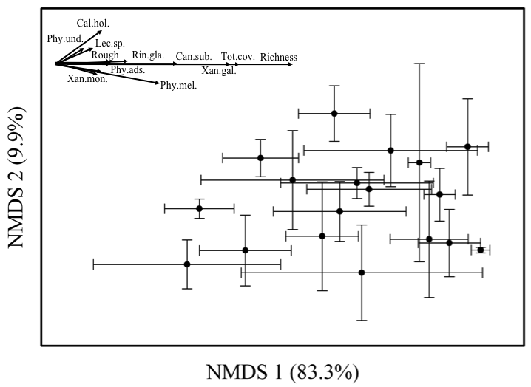Figure 2.

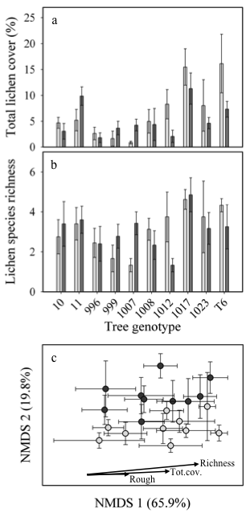Figure 3.

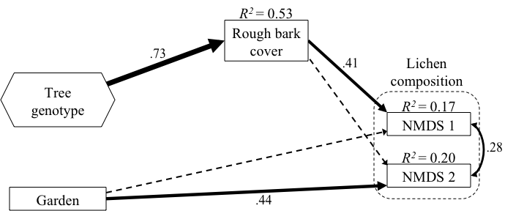

Figure 4.

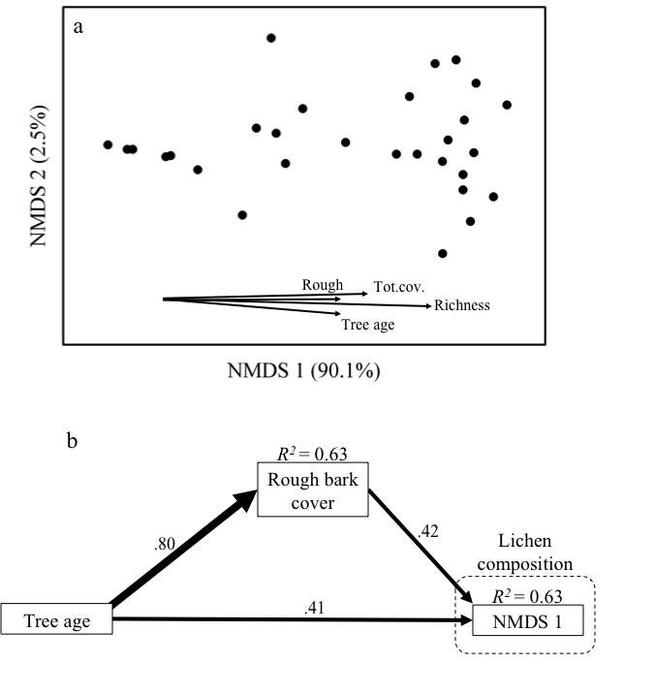

Figure 5.

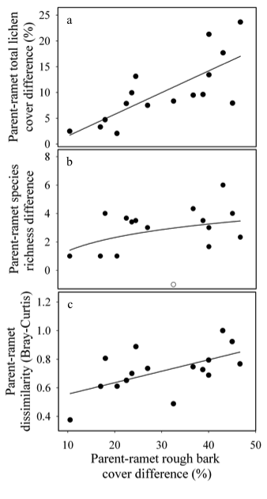

Supplement 2. Number of trees and approximate locations of original collection sites for tree genotypes from each dataset. Site coordinates are for the approximate location of the stand a collection was made but not the exact location of each tree.

|  |  |  |  |  |  |  |  |  |  |  |  |  |  |
| --- | --- | --- | --- | --- | --- | --- | --- | --- | --- | --- | --- | --- | --- |
|  | Number of trees used in each dataset | | | | | | | | | Location of original collection sites for propagation of common garden trees | | | |
| Tree genotype code name | Full ONC garden heritability dataset |  | GxE dataset from ONC garden | GxE dataset from Pit garden |  | Single stand origin GxE dataset from ONC garden | Single stand origin GxE dataset from Pit garden |  | ONC garden Parent-Ramet dataset | Site name | Latitude | Longitude | Elevation (m) |
| 10 | 4 |  | 4 | 5 |  |  |  |  | 2 | Uinta | 41.138357 | -111.946506 | 1361 |
| 11 | 5 |  | 5 | 5 |  |  |  |  | 5 | Uinta | 41.138357 | -111.946506 | 1361 |
| 13 |  |  |  |  |  |  |  |  | 3 | Horseshoe bend | 41.139203 | -111.858514 | 1460 |
| 996 | 9 |  | 9 | 5 |  | 9 | 5 |  | 4 | Screen | 41.135735 | -111.898550 | 1394 |
| 999 | 3 |  | 3 | 9 |  |  |  |  | 2 | Horseshoe bend | 41.139203 | -111.858514 | 1460 |
| 1000 |  |  |  |  |  |  |  |  | 3 | Screen | 41.135735 | -111.898550 | 1394 |
| 1005 | 4 |  |  |  |  |  |  |  |  | Screen | 41.135735 | -111.898550 | 1394 |
| 1007 | 3 |  | 3 | 7 |  | 3 | 7 |  |  | Screen | 41.135735 | -111.898550 | 1394 |
| 1008 | 8 |  | 8 | 6 |  | 8 | 6 |  | 2 | Screen | 41.135735 | -111.898550 | 1394 |
| 1012 | 4 |  | 4 | 3 |  | 4 | 3 |  |  | Screen | 41.135735 | -111.898550 | 1394 |
| 1017 | 8 |  | 8 | 7 |  | 8 | 7 |  | 3 | Screen | 41.135735 | -111.898550 | 1394 |
| 1023 | 4 |  | 4 | 6 |  | 4 | 6 |  | 2 | Screen | 41.135735 | -111.898550 | 1394 |
| EC1 | 3 |  |  |  |  |  |  |  |  | East Canyon | 40.873931 | -111.582153 | 1758 |
| H10 | 3 |  |  |  |  |  |  |  | 3 | Hull | 41.168889 | -111.997833 | 1334 |
| HE2 |  |  |  |  |  |  |  |  | 2 | Henifer | 41.039939 | -111.514986 | 1615 |
| HE7 |  |  |  |  |  |  |  |  | 2 | Henifer | 41.039939 | -111.514986 | 1615 |
| HE10 | 2 |  |  |  |  |  |  |  |  | Henifer | 41.039939 | -111.514986 | 1615 |
| RL1 |  |  |  |  |  |  |  |  | 2 | Rockport Lake | 40.793892 | -111.405836 | 1864 |
| RL2 |  |  |  |  |  |  |  |  | 2 | Rockport Lake | 40.793892 | -111.405836 | 1864 |
| RL6 | 3 |  |  |  |  |  |  |  |  | Rockport Lake | 40.793892 | -111.405836 | 1864 |
| RM2 | 3 |  |  |  |  |  |  |  |  | Taggart-Ready mix | 41.057931 | -111.586372 | 1583 |
| T6 |  |  | 3 | 4 |  |  |  |  | 3 | Taggart-Ready mix | 41.057931 | -111.586372 | 1583 |
| T15 | 3 |  |  |  |  |  |  |  |  | Taggart-Ready mix | 41.057931 | -111.586372 | 1583 |
| WC5 | 4 |  |  |  |  |  |  |  | 3 | Weber Canyon | 40.738803 | -111.242224 | 2039 |
| Total: | 73 |  | 51 | 57 |  | 36 | 34 |  | 43 |  |  |  |  |

Supplement 2. Relative lichen abundances (proportion of total cover) for the full ONC garden (A), GxE (B), chronosequence (C) and Parent-Ramet ONC datasets, with Pearson’s correlations for vectors analyses with respective ordinations and indicator species analyses, when conducted.

A.

|  |  |  |  |
| --- | --- | --- | --- |
| Lichen species | Relative abundance | Correlations (*r*) with NMDS axes  Figure 1 | |
|  |  | Axis 1 | Axis 2 |
| *Xanthomendoza galericulata* | 0.8990 | 0.728 | 0.016 |
| *Candelariella subdeflexa* | 0.0722 | 0.608 | 0.023 |
| *Physciella melanchra* | 0.0105 | 0.586 | -0.265 |
| *Caloplaca holocarpa* | 0.0069 | 0.382 | 0.285 |
| *Physcia adscendens* | 0.0033 | 0.349 | -0.131 |
| *Lecanora sp.* 1 | 0.0032 | 0.345 | 0.203 |
| *Xanthomendoza montana* | 0.0022 | 0.359 | -0.012 |
| *Physcia undulata* | 0.0018 | 0.288 | 0.193 |
| *Rinodina glauca* | 0.0009 | 0.470 | 0.100 |
| Total lichen cover |  | 0.752 | -0.010 |
| Species Richness |  | 0.920 | 0.041 |
| Rough bark cover |  | 0.330 | 0.034 |

Supplement 2. Continued

|  |  |  |  |  |  |  |
| --- | --- | --- | --- | --- | --- | --- |
| Lichen species | Relative abundance | | Correlations (*r*) with NMDS axes  Figure 2C | | Indicator species analysis between gardens | |
|  | Pit | ONC | Axis 1 | Axis 2 | *P* | Garden |
| *Xanthomendoza galericulata* | 0.8336 | 0.9117 | 0.687 | 0.000 | 0.236 | ONC |
| *Xanthomendoza montana* | 0.1033 | 0.0013 | 0.302 | 0.570 | 0.001 | Pit |
| *Candelariella subdeflexa* | 0.0275 | 0.0646 | 0.508 | -0.096 | 0.005 | ONC |
| *Physcia undulata* | 0.0116 | 0.0016 | 0.314 | 0.091 | 0.050 | Pit |
| *Physciella melanchra* | 0.0094 | 0.0087 | 0.531 | -0.180 | 0.084 | ONC |
| *Lecanora sp.* 1 | 0.0077 | 0.0027 | 0.328 | 0.319 | 0.102 | Pit |
| *Physcia adscendens* | 0.0030 | 0.0024 | 0.232 | 0.196 | 0.189 | Pit |
| *Caloplaca holocarpa* | 0.0029 | 0.0065 | 0.266 | 0.134 | <0.001 | ONC |
| *Melanelia elegantula* | 0.0005 | 0.000 | 0.061 | 0.080 | 0.507 | Pit |
| *Rinodina glauca* | 0.0004 | 0.0005 | 0.331 | 0.126 | 0.637 | ONC |
| *Lecanora hagenii* | 0.0001 | 0.000 | 0.117 | 0.083 | 1.000 | Pit |
| Total lichen cover |  |  | 0.751 | 0.111 |  |  |
| Species Richness |  |  | 0.895 | 0.266 |  |  |
| Rough bark cover |  |  | 0.407 | 0.000 |  |  |

B.

C.

|  |  |  |  |
| --- | --- | --- | --- |
| Lichen species | Relative abundance | Correlations (*r*) with NMDS Axes Figure 4A | |
|  |  | Axis 1 | Axis 2 |
| *Xanthomendoza galericulata* | 0.6269 | 0.920 | -0.112 |
| *Xanthomendoza montana* | 0.1496 | 0.719 | -0.032 |
| *Lecanora sp.* 1 | 0.0739 | 0.775 | 0.015 |
| *Candelariella subdeflexa* | 0.0480 | 0.788 | -0.073 |
| *Rinodina glauca* | 0.0417 | 0.672 | 0.186 |
| *Physciella melanchra* | 0.0397 | 0.429 | -0.672 |
| *Phaeophyscia orbicularis* | 0.0126 | 0.357 | 0.426 |
| *Phaeophyscia ciliata* | 0.0025 | 0.287 | 0.029 |
| *Lecanora hagenii* | 0.0022 | 0.416 | -0.342 |
| *Melanelia elegantula* | 0.0011 | 0.321 | -0.051 |
| *Physcia adscendens* | 0.0012 | 0.431 | 0.031 |
| *Caloplaca holocarpa* | 0.0005 | 0.478 | -0.444 |
| *Melanelia subolivacea* | 0.0002 | 0.171 | 0.083 |
| Total lichen cover |  | 0.792 | 0.039 |
| Species Richness |  | 0.928 | -0.139 |
| Rough bark cover |  | 0.751 | -0.017 |
| Tree age |  | 0.748 | -0.272 |

D.

|  |  |  |
| --- | --- | --- |
| Lichen species | Relative abundance | |
|  | Parent trees | Ramets |
| *Xanthomendoza galericulata* | 0.8562 | 0.9041 |
| *Candelariella subdeflexa* | 0.1079 | 0.0000 |
| *Xanthomendoza montana* | 0.0128 | 0.0000 |
| *Physciella melanchra* | 0.0075 | 0.0126 |
| *Lecanora sp.* 1 | 0.0073 | 0.0000 |
| *Caloplaca holocarpa* | 0.0035 | 0.0000 |
| *Rinodina glauca* | 0.0023 | 0.0023 |
| *Physcia adscendens* | 0.0014 | 0.0136 |
| *Physcia undulata* | 0.0007 | 0.0665 |
| *Phaeophyscia orbicularis* | 0.0003 | 0.0003 |
| *Lecanora hagenii* | 0.0001 | 0.0003 |
| *Lecanora sp.* 2 | <0.0001 | 0.0003 |

Supplement 3. Species’ covers in relation to rough bark, at common gardens (ONC = left, Pit = center), and the Uinta natural stand (right). Each row of graphs corresponds to a lichen species, and graphs are excluded when a species does not occur at a site. Box plots (median, quartile, range) for each garden are ranked by increasing average rough bark cover (in parentheses after genotype labels), while scatter plots from the Uinta site are fit with lowess splines. Note the variation in y-axis scales.

NOTE to reader: I am still working on fine-tuning the graph panels in Supplement 3, so any suggestions for improvement would be great.

Supplement 3. Continued.

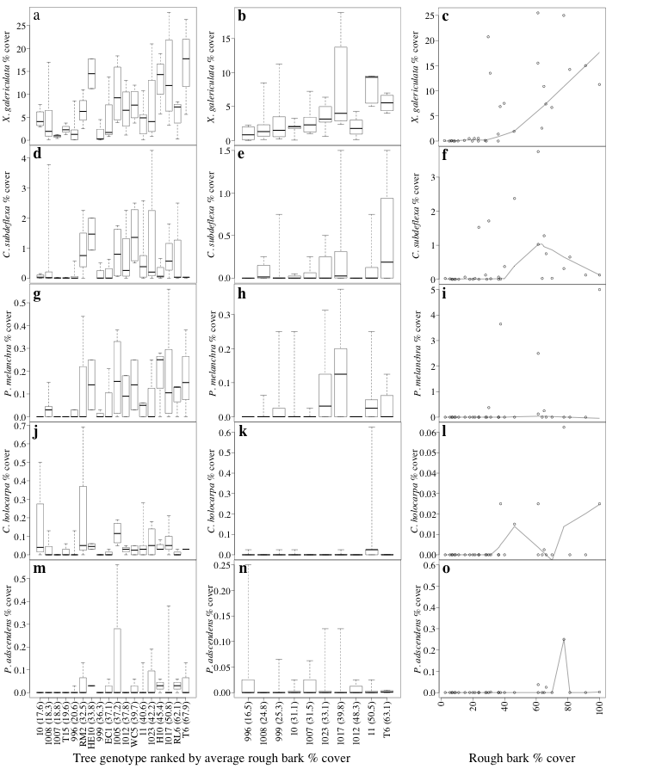Supplement 3. Continued

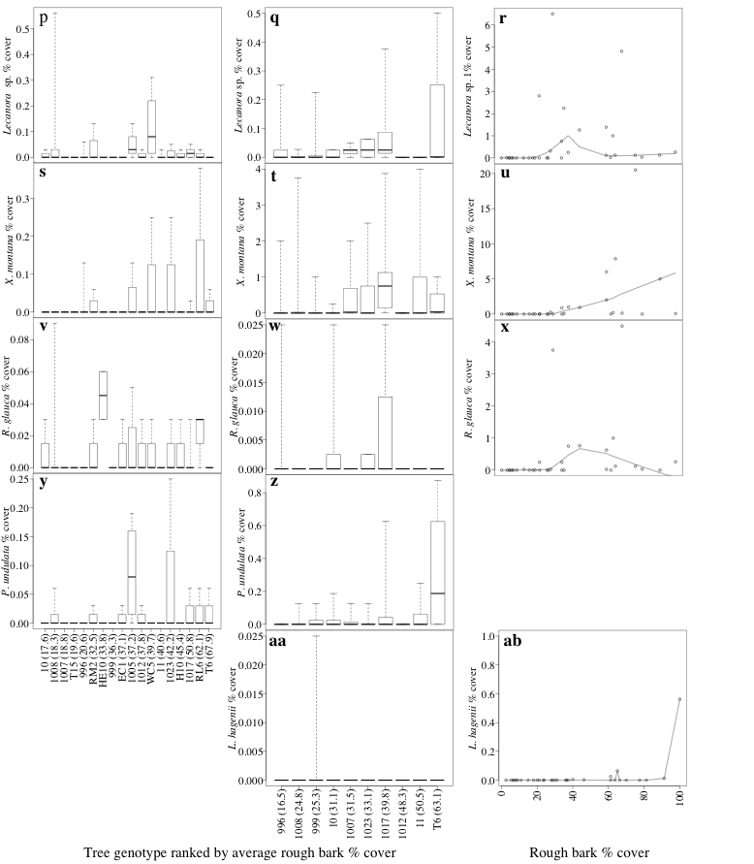

Supplement 3. Continued

